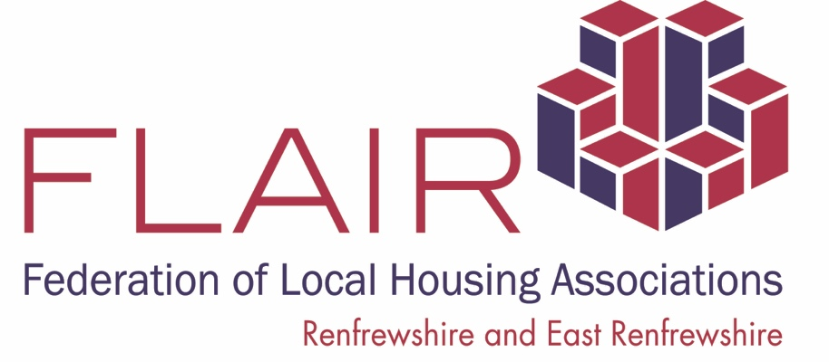

HAVE YOU A FLAIR FOR HELPING YOUR COMMUNITY?

Housing Associations in new recruitment drive

Housing associations in Renfrewshire and East Renfrewshire have launched a recruitment drive for people willing to help their communities.

The aim is to recruit individuals to serve on the Boards – sometimes known as Management Committees - of housing associations and ultimately make a difference.

A number of housing associations run what’s known as the FLAIR Academy – a FREE training initiative designed to provide all you need to know about what serving with a housing association entails.
The reward is that you are involved in the decision-making process on housing and regenerating communities – all part of the inspiring work housing associations undertake.

FLAIR is made up of the following housing providers: Barrhead HA, Bridgewater HA, Ferguslie Park HA, Linstone HA, Paisley HA and Williamsburgh HA.

FLAIR is particularly keen to recruit people who are under represented in the housing sector. FLAIR positively encourages applications from individuals regardless of sex, race, disability, sexual orientation, age or religion or beliefs.

If you are looking for a way to have a voice in the housing sector this opportunity might for you.

FLAIR can offer continuing professional development, real life experience for your CV, volunteering with meaning and purpose, networking with professionals and others committed to social impact and ultimately a way of helping improve communities and lives.

Being part of the FLAIR ACADEMY lasts 9 weeks and there are 2 semesters – April to June and Oct to Dec every year. It requires around 6 hours per month. All training materials, resources and reasonable expenses are covered.
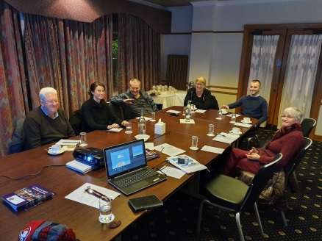
There is 1 session every Tuesday evening from 20th April to 15th June 2021. These training sessions will be held virtually this year.

Further details are available from FLAIR on 0141 583 4124

