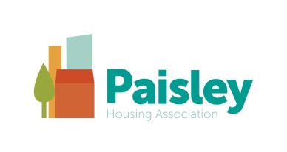
Paisley HA Advice Team
If you are having financial difficulties, we can help!
We know that times are hard just now with the pandemic changing so many peoples circumstances. In recognising this we have expanded our advice services during this to support our tenants.
You may not have thought to use our services before but we have helped numerous tenants maximise their income and reduce outgoings – Let us see what we can do for you.
Our advice team can help you;:
- Identify and claim, any benefits or grants that you are entitled to
- Challenge or appeal, unfair benefit decisions
- Ensure that you are on the cheapest available tariff for your gas and electricity
- Deal with gas and electricity debt .
- Reduce deductions from your benefits
- Get help with debts
- Access digital services
Digital Services
We also have a Digital Engagement Assistant, Claire Ballantyne, who is currently working on increasing our communications with our customers through our Website and Facebook. Please have a look at our website at paisleyha.org.uk or follow our facebook page. In the coming months, Claire will be offering assistance to our tenants who are experiencing difficulties getting on line or in using their device.
Why not contact us and see what we can do for you?
How to contact our Advice Team;
- Email adviceteam@paisleyha.org.uk
- Telephone, Text or Whatsapp Message to:
Welfare Benefits: Alan Graham 07737 635 089
Welfare Benefits & Budgeting Advice: George MacPhail 07812 186 522
Energy Advice: Ben Wilson 07737 728 785
Digital Advice Claire Ballantyne 0141 889 7105

*If texting or using whatsapp please give your name and address in the message.
Scottish Charity No. SC035589

